**PROJECT’S OBJECTIVE :**

The objective of this project is to thoroughly examine the website traffic data to gain insights into user behavior and engagement. By analyzing metrics such as page loads, unique visits, first-time visits, and returning visits

**ARCHITECTURE OF OUR PROJECT**

START

DATA COLLECTION

DATA PREPROCESSING

DATA STORAGE

DATA ANALYSIS

DATA STORAGE

GENERATE REPORTS

INTERPRET RESULTS

IMPLEMENT CHANGES

MONITOR AND OPTIMIZE

END

In the digital landscape, understanding website traffic is pivotal for optimizing user experience and bolstering online presence. This project follows a systematic approach encompassing data collection, preprocessing, analysis, report generation, and interpretation of results.

**Data Collection and Preprocessing:**  
Raw data is sourced from diverse channels, including analytics tools and user interactions. This data undergoes rigorous cleaning and preprocessing, ensuring accuracy and reliability. Normalization and categorization refine the dataset for effective analysis.

**Analysis and Reporting:**  
Advanced statistical methods and machine learning algorithm(LINEAR REGRESSION) are employed to extract valuable insights from the pre-processed data. Patterns and trends in user behaviour, popular content, and visitor demographics are identified. The findings are compiled into a comprehensive report, featuring visual representations and key performance indicators.  
  
**Interpretation and Implementation:**The report is interpreted to draw actionable suggestions. Website owners are presented with these insights, guiding them in implementing changes ranging from redesigning elements to optimizing loading speeds. Implementation is key to enhancing user experience and overall satisfaction.  
  
**Monitoring and Optimization:**Post-implementation, continuous monitoring is imperative. Regular analyses and real-time user feedback drive further optimizations. This iterative process ensures websites remain user-friendly, meeting evolving expectations and trends in the digital sphere.  
  
In essence, this project empowers website owners with data-driven decision-making, enabling them to create engaging platforms that attract and retain satisfied visitors, ensuring sustained success online.

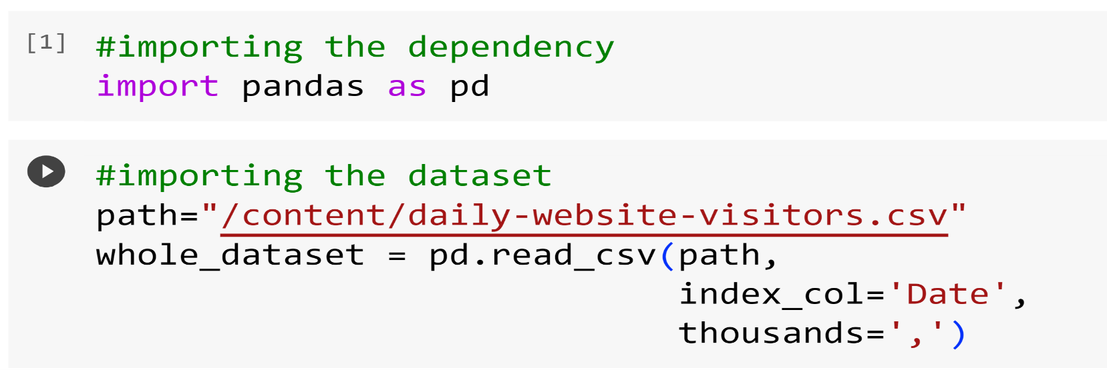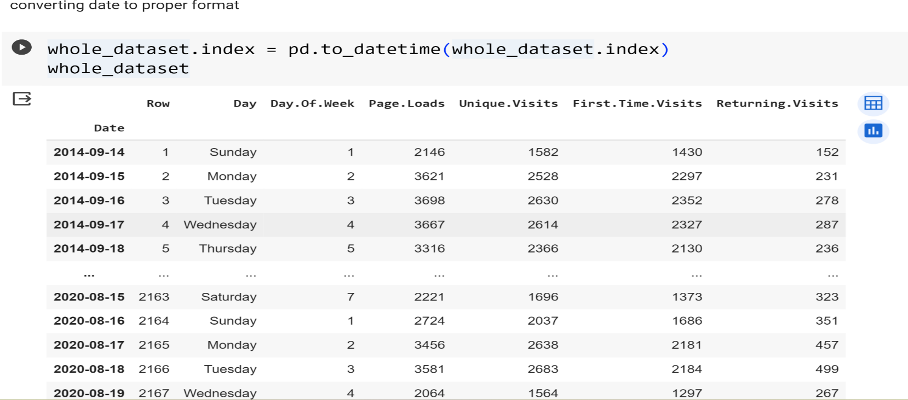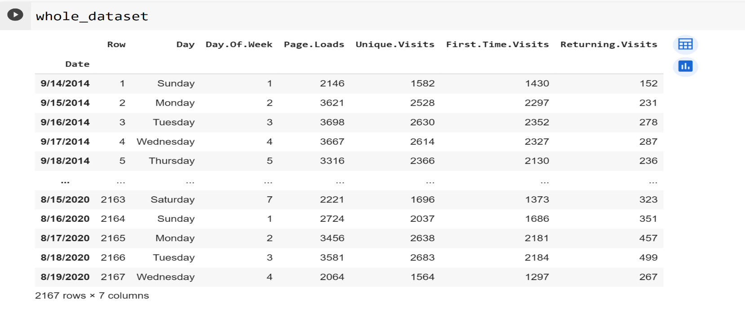**DATA CLEANING AND ANALYSIS**

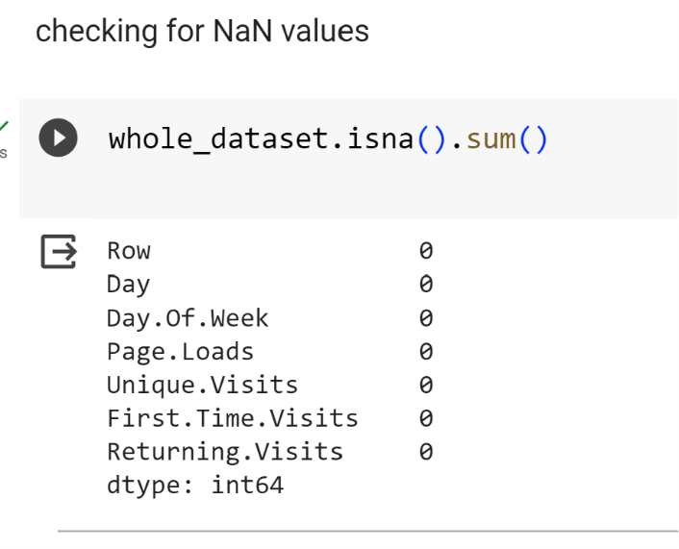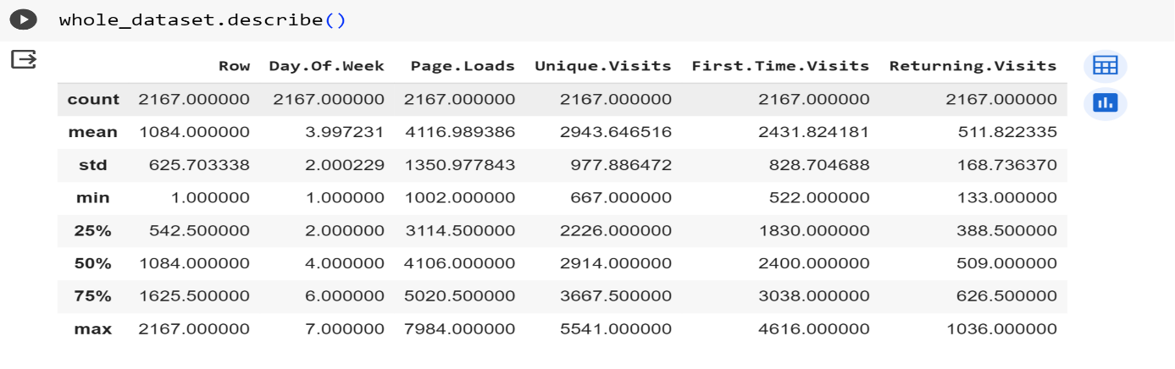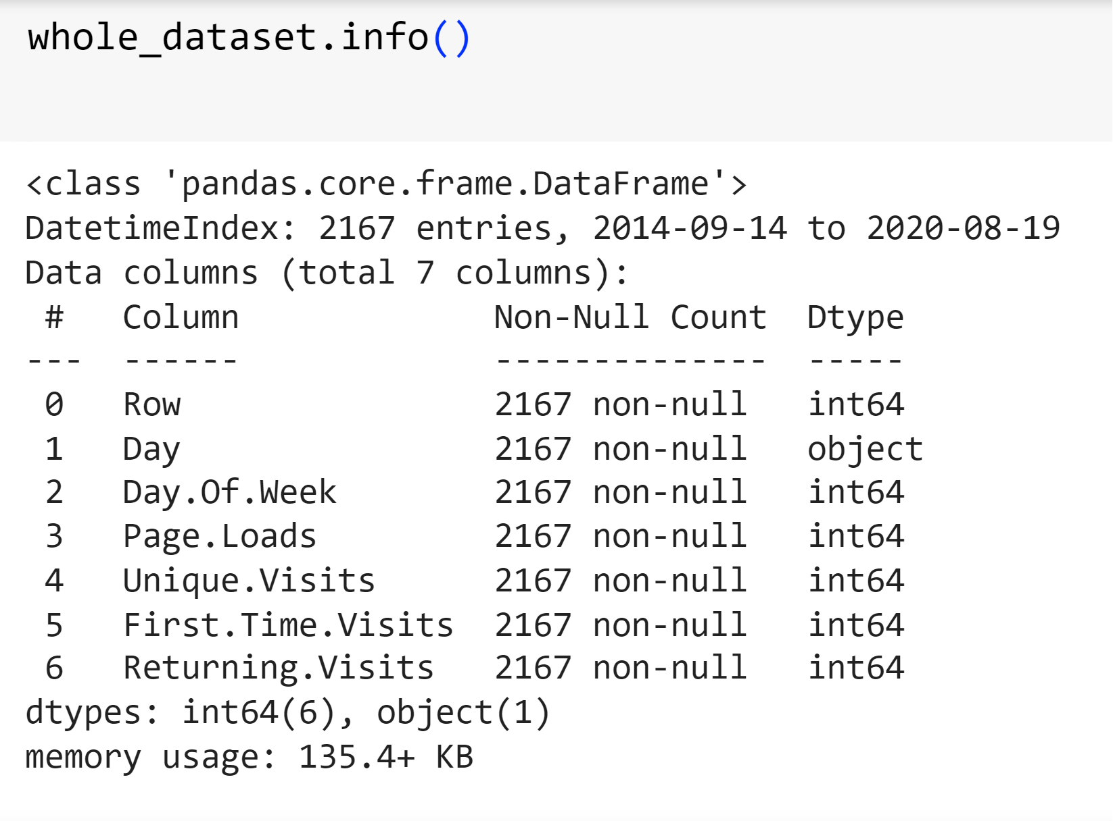**DESCRIPTION AND INFORMATION**

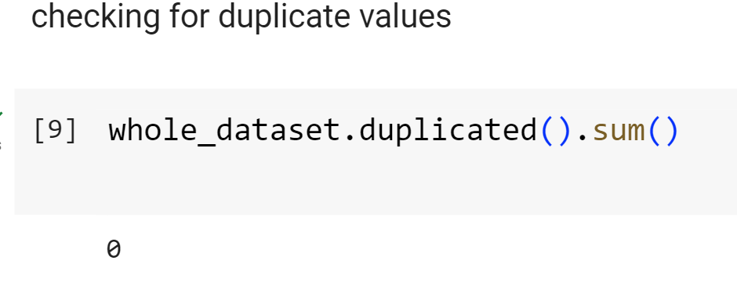

**DATA VISUALIZATION**

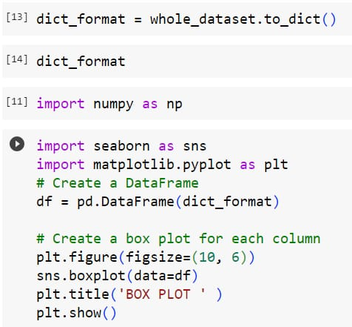

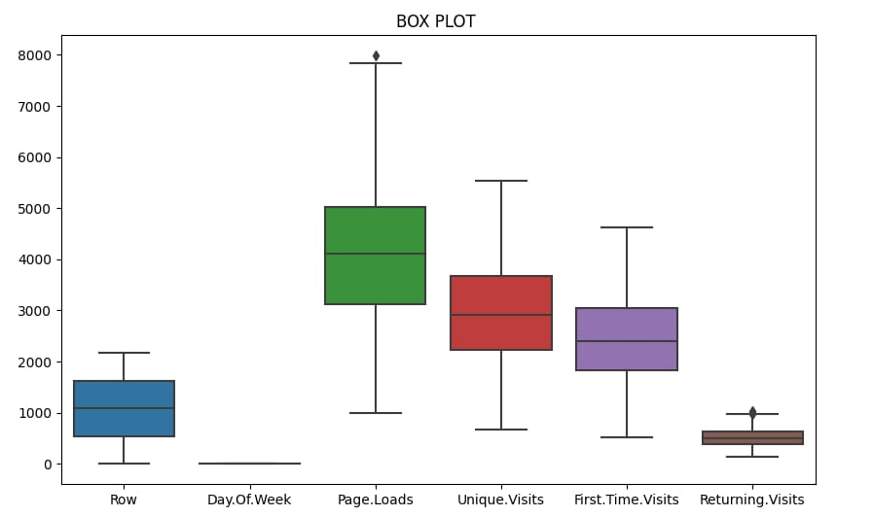

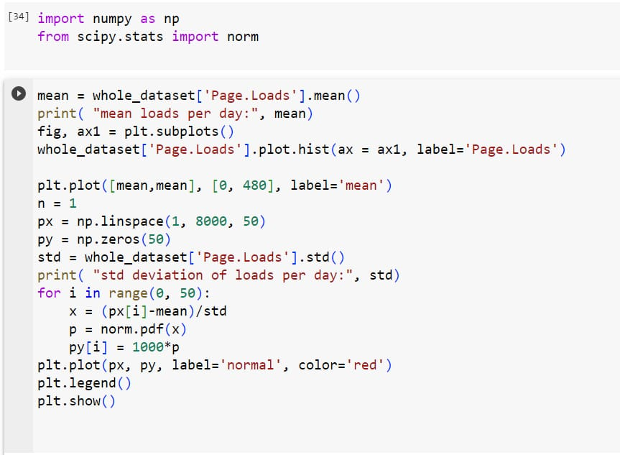

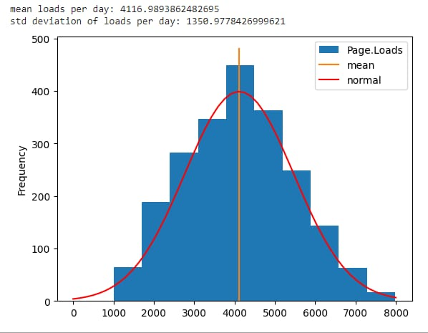

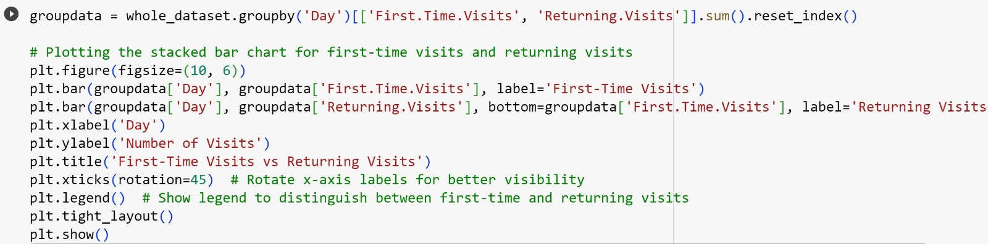

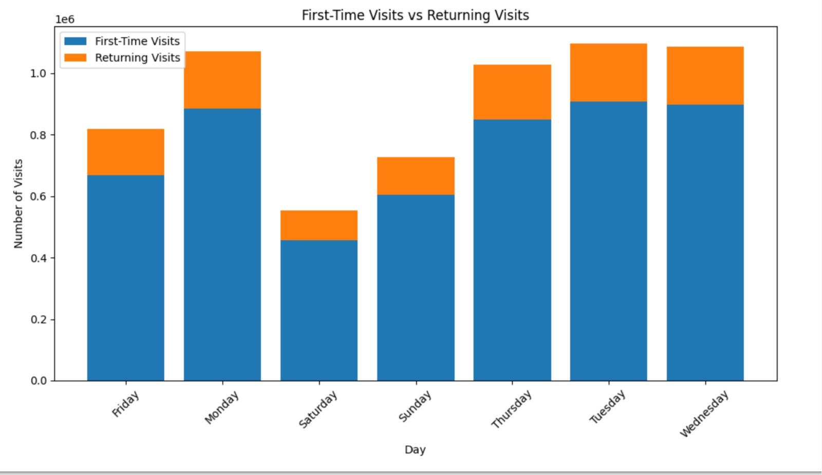

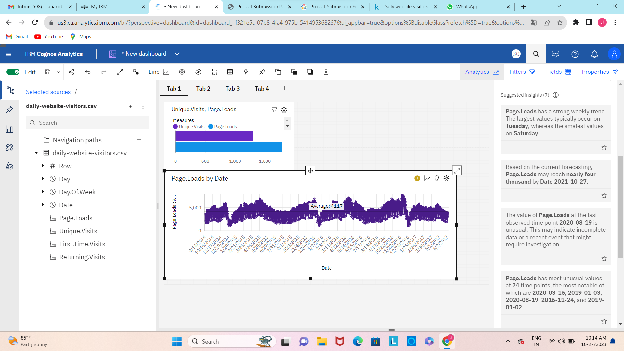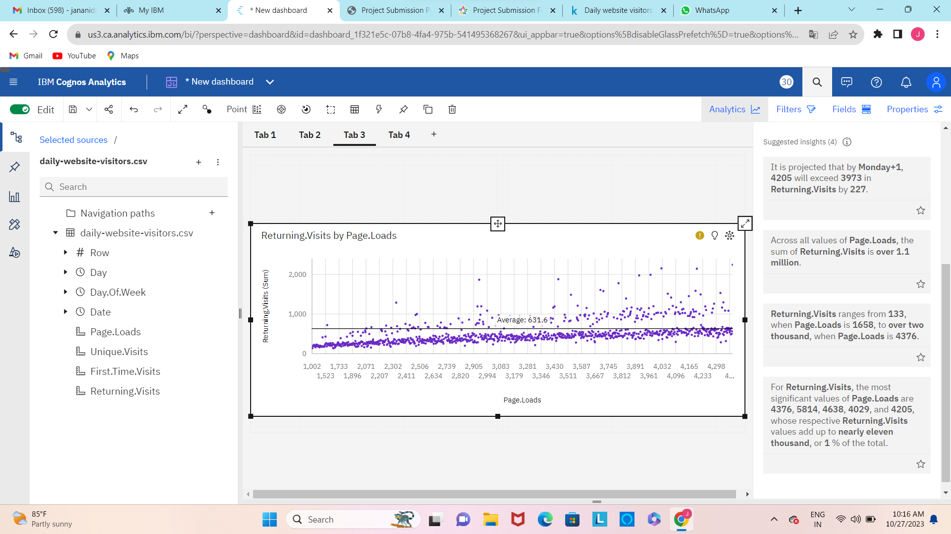**VISUALIZATION USING IBM COGNOS**

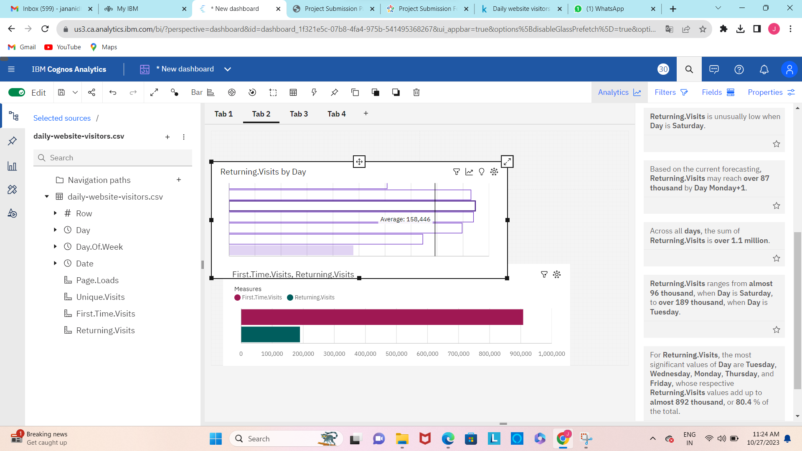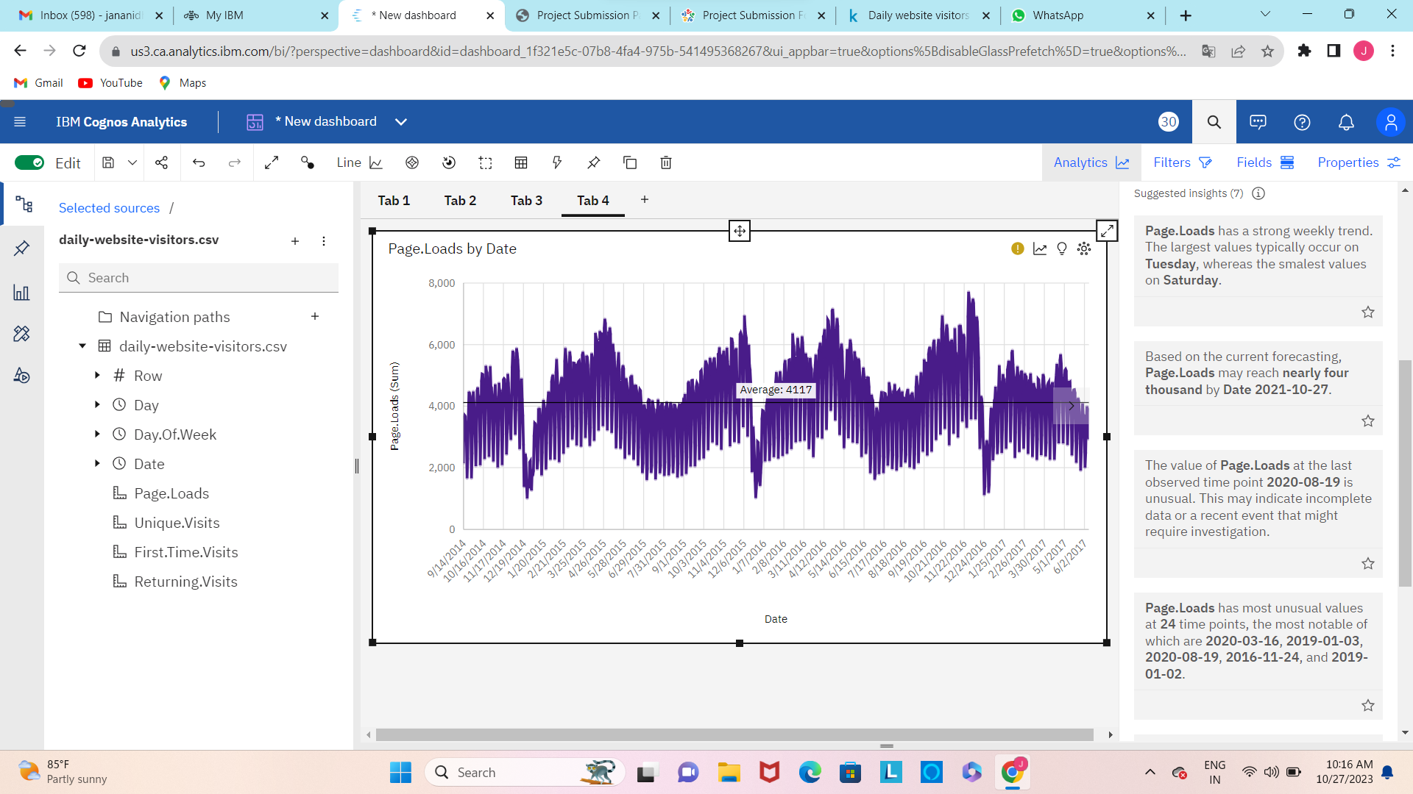

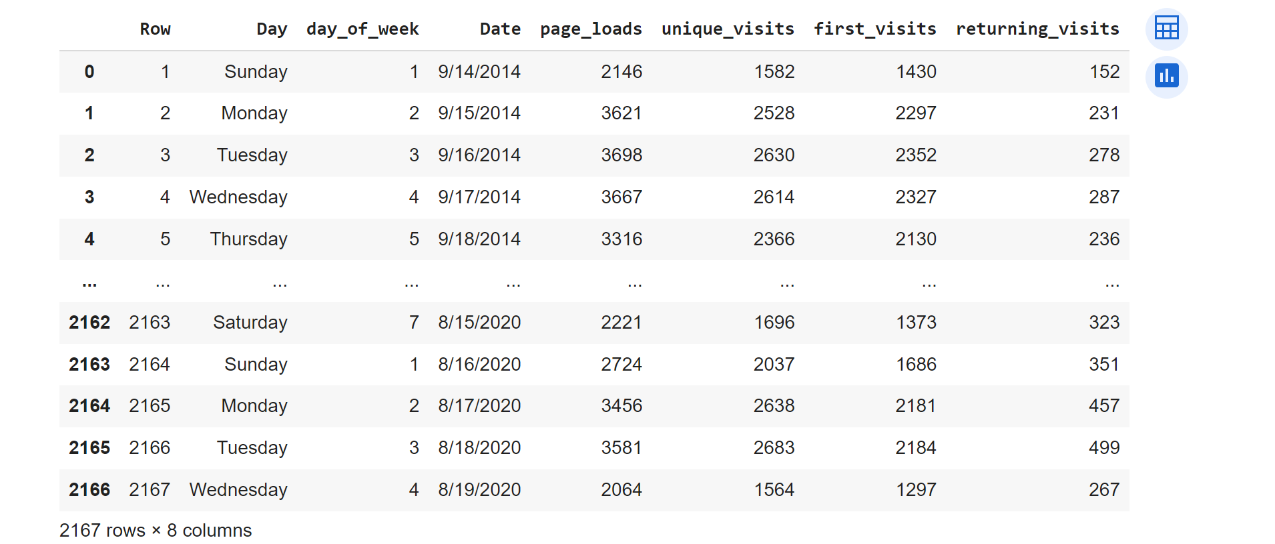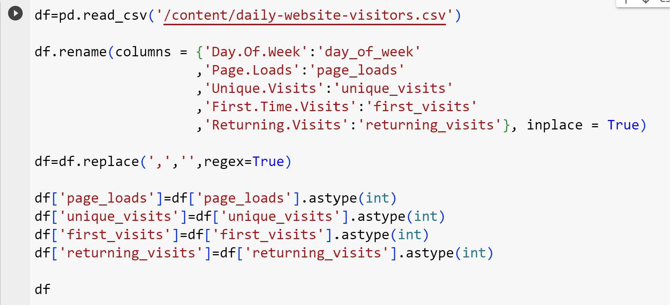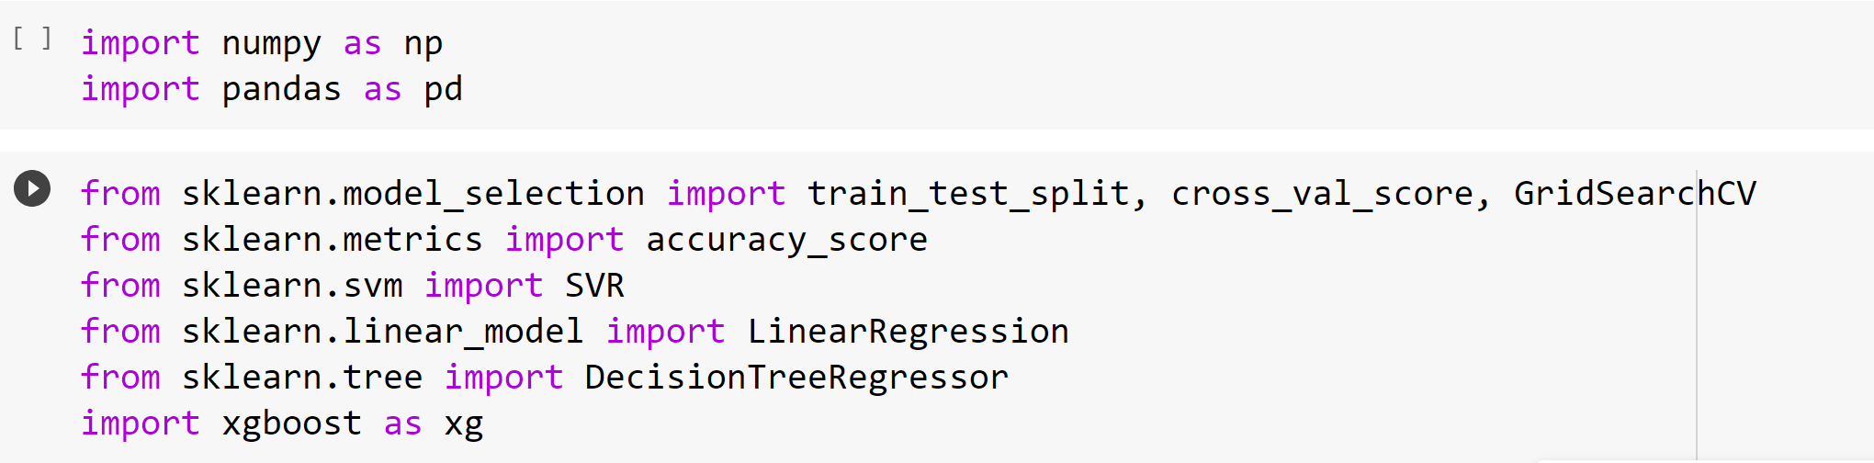**MACHINE LEARNING PREDICTION USING LINEAR REGRESSION**

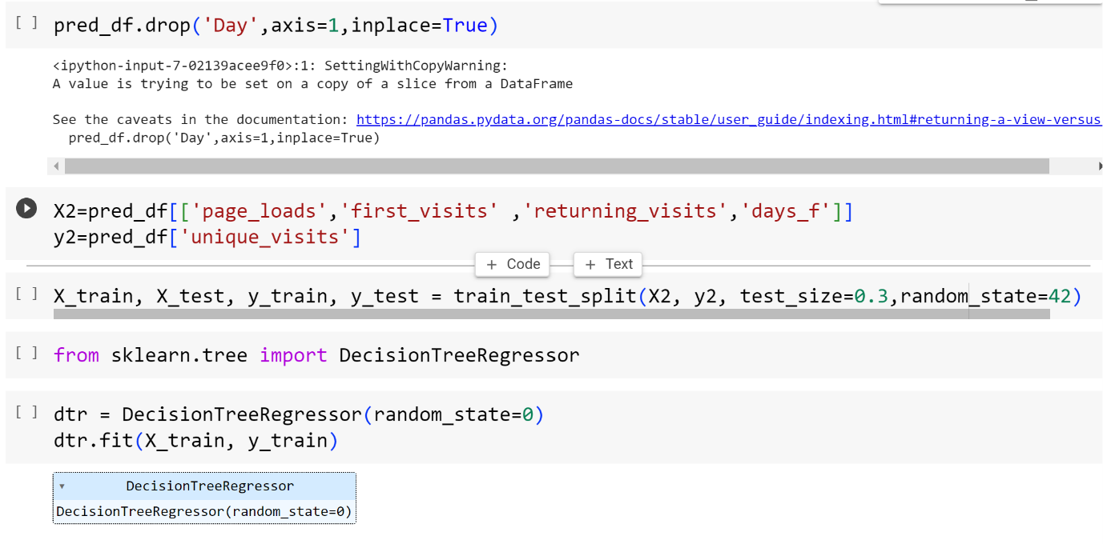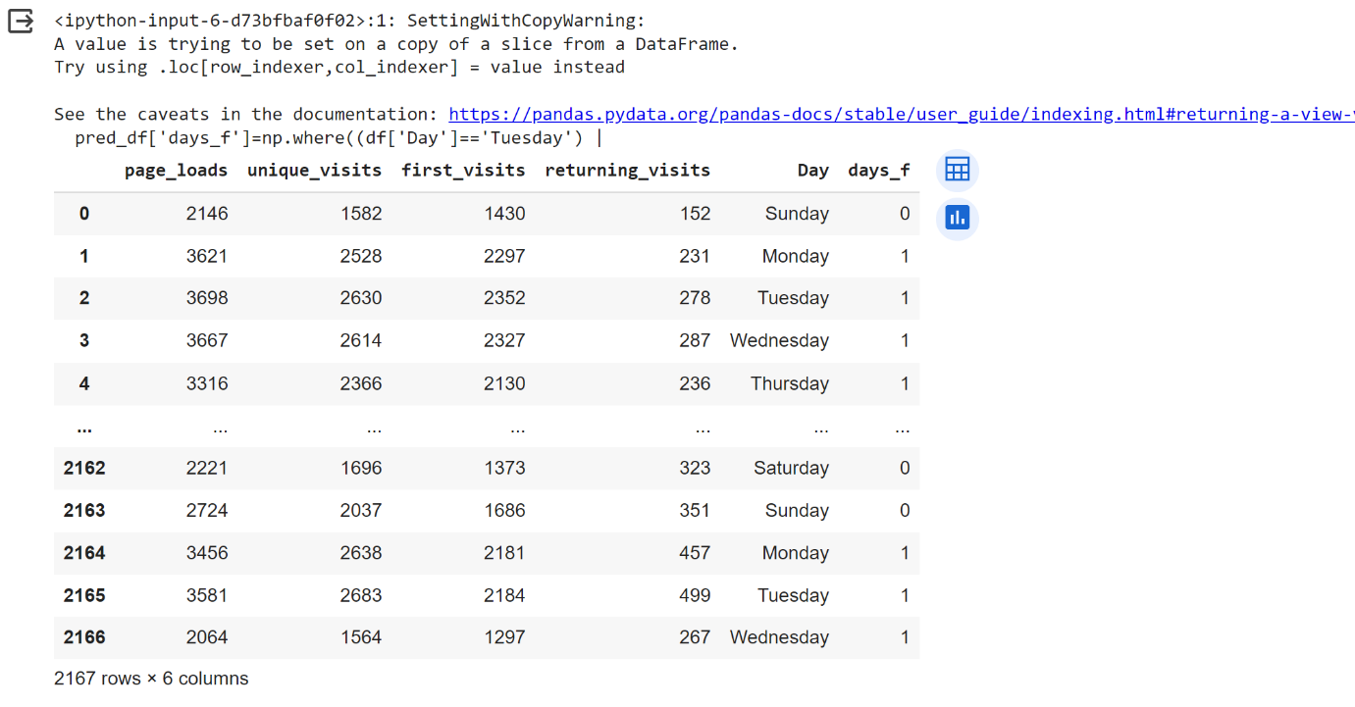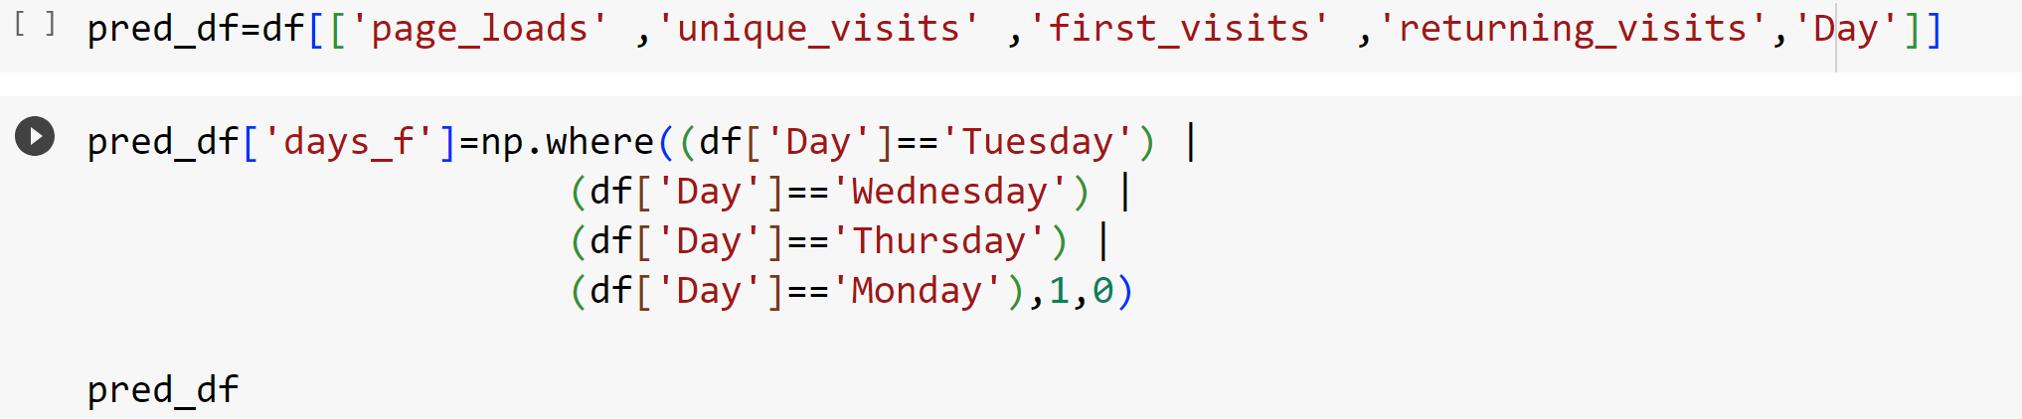

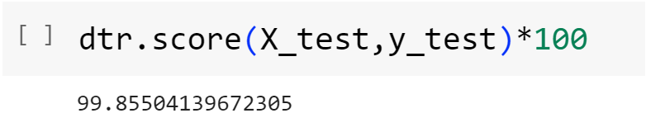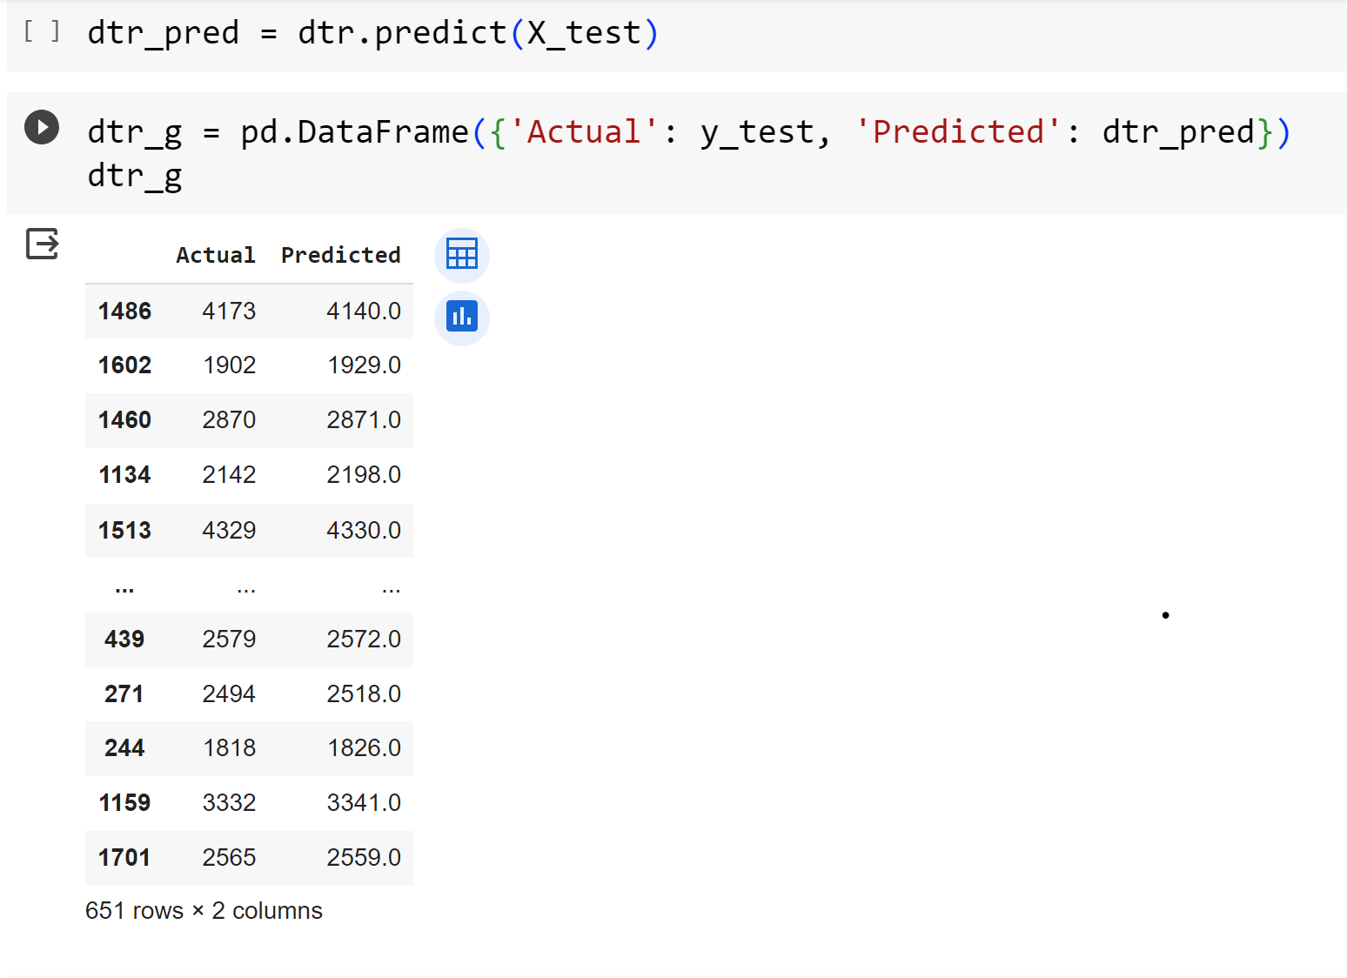

**INSIGHTS FROM THE ANALYSIS:**

**1. Identifying Popular Content :**

By understanding which pages or content receive the most visits, owners can focus on creating more of what resonates with users, thereby increasing engagement and satisfaction.

**2. Reducing Bounce Rates :**

Insights can reveal which pages have high bounce rates. This indicates that users are leaving the site quickly, possibly due to issues like slow loading times, unappealing content, or confusing navigation. Addressing these issues can improve user retention.

**3. Optimizing Content and Layouts :**

Analysis helps owners identify which elements on a page are most engaging or effective. They can then replicate these successful elements across the website to create a more consistent and appealing user experience.

**4. Understanding User Behavior :**

Insight into how users navigate the website (e.g., which pages they visit in succession) can inform the organization and structure of the content. This helps users find what they're looking for more easily.

**5. Personalization and Targeting :**

Analysis can provide insights into user segments based on behavior, demographics, or preferences. This information enables website owners to deliver personalized content, offers, and recommendations, enhancing the user experience.

**6. Enhancing Page Load Speed :**

- Slow-loading pages can frustrate users and lead to higher bounce rates. By identifying and rectifying factors that contribute to slow loading times, owners can create a smoother and more efficient browsing experience.